**Abstract:**

In the ever-evolving landscape of healthcare, the integration of prompt engineering and artificial intelligence (AI) heralds a new era in medical diagnosis. However, amidst the promise of revolutionizing diagnostic practices, significant challenges persist. From the timely detection of diseases to the accurate interpretation of complex medical data, healthcare professionals grapple with the need for more efficient and precise diagnostic methods. In response, the synergy between prompt engineering and AI offers a beacon of hope, promising to streamline the diagnostic process and enhance patient outcomes.

This study aims to explore the transformative potential of integrating prompt engineering and artificial intelligence (AI) in the field of medical diagnosis. Through a comprehensive review of existing research literature such as PubMed, analysis of case studies, and examination of real-world implementations, this study will delve into specific examples such as the use of AI for early detection of cancer and the application of prompt engineering principles in improving diagnostic accuracy, AI-powered patient care by using AI virtual healthcare assistance, AI mental health support and AI in patient education and cost optimization. With a focus on interdisciplinary collaboration, enhanced patient care, and the harnessing of advanced technologies, this study seeks to shed light on how these innovative approaches can revolutionize diagnostic practices. Furthermore, the case study addresses critical challenges such as patient data privacy, transparency, and accountability. Thus, this case study endeavors to explore the transformative potential of prompt engineering and AI in addressing these challenges while revolutionizing medical diagnosis for the betterment of healthcare delivery and patient care.

**Introduction:**

The landscape of medical diagnosis is undergoing a significant transformation, driven by the integration of advanced technologies such as artificial intelligence (AI). As highlighted by Taylor [[3](https://www.medtechdive.com/news/duke-report-identifies-barriers-to-adoption-of-ai-healthcare-systems/546739/)], diagnostic errors account for a staggering 60% of all medical errors in U.S. hospitals, resulting in an estimated 40,000 to 80,000 deaths annually [[2](https://www.businessnewsdaily.com/15096-artificial-intelligence-in-healthcare.html)]. The imperative to reduce these errors has spurred the adoption of AI-based technologies across various healthcare fields, aiming to augment human judgment and improve diagnostic accuracy.

Premier healthcare institutions like the Mayo Clinic and Moorfields Eye Hospital have been at the forefront of this technological revolution. For instance, the Mayo Clinic has leveraged AI for cervical cancer screening, achieving remarkable accuracy rates surpassing those of human experts [[4](https://healthcareweekly.com/artificial-intelligence-in-healthcare/), [5](https://www.mddionline.com/can-ai-really-be-game-changer-cervical-cancer-screenings)]. Similarly, Moorfields Eye Hospital in London has implemented AI solutions to identify eye disease signs with unparalleled precision, matching the diagnostic capabilities of world-leading doctors and experts [[6](https://www.moorfields.nhs.uk/news/breakthrough-ai-technology-improve-care-patients)]. These examples underscore the potential of AI to significantly enhance diagnostic efficiency and efficacy [[1](https://www.ncbi.nlm.nih.gov/pmc/articles/PMC7795119/)].

The benefits of AI in medical diagnosis extend beyond mere accuracy. At the Gachon University Gil Medical Center in South Korea, there was a 55.9% consensus rate between medical staff and Watson in evaluating medical treatment outcomes over a year (2017). However, for patients with stage IV stomach cancer, the consensus rate dropped to 40%. Additionally, in April 2018, Konyang University Hospital in South Korea reported a 48% consensus rate between doctors' decisions and Watson's treatment recommendations, based on 100 breast cancer patients [[7](http://biz.chosun.com/site/data/html_dir/2018/11/23/2018112302467.html)].

Liang et al. investigated the "evaluation and accurate diagnoses of pediatric diseases using AI" at the Guangzhou Women and Children’s Medical Center in Guangdong Province, China. They employed AI-based technologies with deep learning techniques using 101 million data points from electronic records of 1.3 million outpatient visits. To compare performance, physicians were divided into five groups based on experience: senior residents (Group 1), junior physicians (Group 2), mid level physicians (Group 3), attending physicians (Group 4), and senior attending physicians (Group 5). The AI model achieved an average accuracy score of 88.5%, outperforming junior physicians but falling slightly behind senior physicians. The study suggested that while the AI model may aid junior physicians, experienced physicians still exhibited superior diagnostic accuracy. The AI system was able to diagnose conditions with accuracy rates ranging from 90 to 95% [[8](https://scholar.google.com/scholar_lookup?journal=Nat.+Med.&title=Evaluation+and+Accurate+Diagnoses+of+Pediatric+Diseases+Using+Artificial+Intelligence&author=H.+Liang&author=B.+Tsui&author=H.+Ni&author=C.+Valentim&author=S.+Baxter&volume=25&publication_year=2019&pages=433-438&pmid=30742121&doi=10.1038/s41591-018-0335-9&)]. Refer to *Fig. 1*

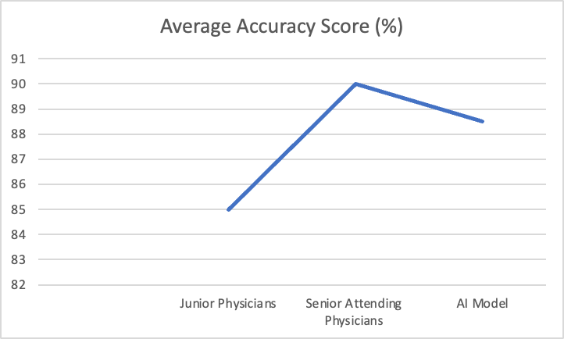

***Fig. 1***

Moreover, the introduction of AI-based diagnostic tools, such as Watson for Oncology at Manifal Hospital in Bangalore, India, has highlighted the transformative impact of AI on multidisciplinary patient care. By analyzing vast datasets and providing evidence-based treatment recommendations, AI not only enhances diagnostic accuracy but also streamlines treatment decision-making processes, leading to improved patient outcomes and satisfaction. As Jeff Lenert of Watson Health at IBM aptly notes, AI has the potential to empower healthcare professionals with comprehensive insights and improve patient care through informed decision-making [[9](https://scholar.google.com/scholar_lookup?journal=Ann.+Oncol.&title=Validation+Study+to+Assess+Pperformance+of+IBM+Cognitive+Computing+System+Watson+for+Oncology+with+Manipal+Multidisciplinary+Tumour+Board+for+1000+Consecutive+Cases:+An+Indian+Experience&author=S.+Somashekhar&author=R.+Kumar&author=A.+Kumar&author=P.+Patil&author=A.+Rauthan&volume=27&publication_year=2016&pages=1-2&pmid=32645814&doi=10.1093/annonc/mdw601.002&)].

Prompt engineering plays a crucial role in enabling the achievements of AI in these instances. By optimizing algorithms, reducing processing times, and enhancing real-time response capabilities, prompt engineering ensures that AI systems can deliver rapid and accurate diagnoses. For example, in the case of cervical cancer screening at the Mayo Clinic, prompt engineering techniques may have facilitated the swift analysis of imaging data, allowing for timely detection and intervention. Similarly, at Moorfields Eye Hospital, prompt engineering principles likely contributed to the seamless integration of AI algorithms into existing diagnostic workflows, ensuring efficient and reliable detection of eye diseases. Thus, the synergy between prompt engineering and AI amplifies the impact of technological advancements in medical diagnosis, ultimately leading to improved patient care and outcomes.

In this evolving landscape of medical diagnosis, the integration of prompt engineering and AI holds immense promise for revolutionizing healthcare delivery. By addressing challenges related to diagnostic accuracy, efficiency, and patient care, this case study seeks to explore the transformative potential of AI-driven diagnostic solutions while navigating critical considerations such as patient data privacy, transparency, and accountability. Through interdisciplinary collaboration and the responsible harnessing of advanced technologies, we aim to pave the way for a future where medical diagnosis is not only more accurate and efficient but also more patient-centered and ethically sound.

**Existing AI tools in Medical Diagnosis:**

Despite remarkable advancements in medicine, effective disease diagnosis remains a global challenge, primarily due to the intricate nature of disease mechanisms and symptoms. However, artificial intelligence (AI) has emerged as a promising solution to revolutionize various aspects of healthcare, particularly diagnosis. Machine learning (ML), a subset of AI, stands out as a powerful tool that utilizes data to enhance diagnostic accuracy, streamline workflow, and automate tasks efficiently and cost-effectively [[10](https://scholar.google.com/scholar_lookup?journal=Nat+Reviews+Neurol&title=Applications+of+machine+learning+to+diagnosis+and+treatment+of+neurodegenerative+Diseases&author=MA+Myszczynska&author=PN+Ojamies&author=AM+Lacoste&author=D+Neil&author=A+Saffari&volume=16&issue=8&publication_year=2020&pages=440-56&doi=10.1038/s41582-020-0377-8&)].

ML techniques, especially those incorporating deep learning methodologies like Convolutional Neural Networks (CNN) and data mining techniques, have shown tremendous potential in identifying key disease patterns within large datasets. These tools are highly applicable across healthcare systems for diagnosing, predicting, or classifying diseases [[11](https://pubmed.ncbi.nlm.nih.gov/35327018)].

In the realm of cancer diagnosis, studies have demonstrated the efficacy of AI systems in interpreting medical imaging data, such as mammograms, for breast cancer detection. For instance, a study conducted in the UK showcased a significant reduction in false positives and false negatives by 5.7% and 9.4%, respectively, when utilizing an AI system for breast cancer diagnosis [[12](https://scholar.google.com/scholar_lookup?journal=Nature&title=International+evaluation+of+an+AI+system+for+breast+cancer+screening&author=SM+McKinney&author=M+Sieniek&author=V+Godbole&author=J+Godwin&author=N+Antropova&volume=577&issue=7788&publication_year=2020&pages=89-94&pmid=31894144&doi=10.1038/s41586-019-1799-6&)]. Similarly, research conducted in South Korea revealed that AI-diagnosed breast cancer cases exhibited higher sensitivity (90%) and accuracy in detecting early-stage cancer compared to radiologists (74%) [[13](https://pubmed.ncbi.nlm.nih.gov/33334578)]. Refer to *Fig. 2*.

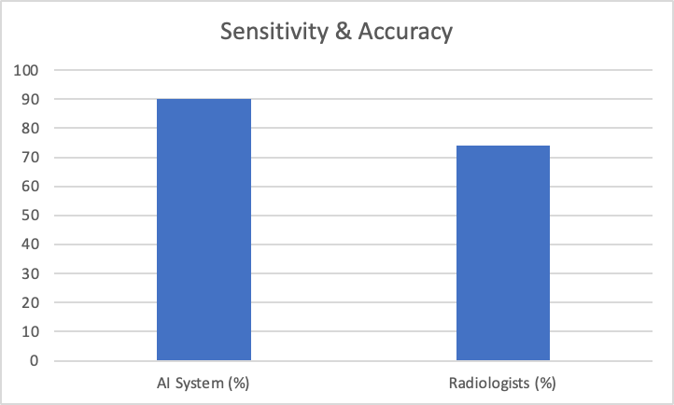

***Fig. 2***

Furthermore, AI-powered tools have shown promise in diagnosing skin cancer, with deep learning algorithms accurately identifying melanoma cases compared to dermatologists and providing treatment recommendations [[14](https://pubmed.ncbi.nlm.nih.gov/32243882), [15](https://pubmed.ncbi.nlm.nih.gov/29846502)]. Beyond cancer, AI technology has been applied in detecting diabetic retinopathy, predicting risk factors for cardiovascular diseases, and identifying abnormalities in medical imaging such as chest radiography [[16](https://www.ncbi.nlm.nih.gov/pmc/articles/PMC8812665/), 17, [18](https://www.ncbi.nlm.nih.gov/pmc/articles/PMC7996054/), [19](https://pubmed.ncbi.nlm.nih.gov/35741276)].

In specific conditions like acute appendicitis, ML techniques have proven beneficial in early diagnosis and treatment planning. Studies utilizing various ML algorithms achieved high accuracy rates, with the random forest algorithm accurately predicting appendicitis in 83.75% of cases [[20](https://www.ncbi.nlm.nih.gov/pmc/articles/PMC8785023/)].

Moreover, AI has demonstrated its potential to transform clinical laboratory testing, particularly in microbiology. ML systems have been developed to detect, identify, and quantify microorganisms, diagnose diseases, and predict clinical outcomes. These systems leverage various data sources, including genomic data, gene sequencing, metagenomic sequencing results, and microscopic imaging, to enhance diagnostic accuracy and efficiency [[21](https://www.ncbi.nlm.nih.gov/pmc/articles/PMC9375890/), [22](https://scholar.google.com/scholar_lookup?journal=Clin+Microbiol+Infect&title=Machine+learning+in+the+clinical+microbiology+laboratory:+has+the+time+come+for+routine+practice?&author=N+Peiffer-Smadja&author=S+Delli%C3%A8re&author=C+Rodriguez&author=G+Birgand&author=FX+Lescure&volume=26&issue=10&publication_year=2020&pages=1300-9&pmid=32061795&doi=10.1016/j.cmi.2020.02.006&)].

In emergency departments (ED), AI algorithms play a crucial role in enhancing efficiency, accuracy, and patient outcomes. By analyzing patient data, AI systems assist in triaging patients based on urgency, optimizing therapy selection, and suggesting emergency department length of stay. These AI-powered decision support systems provide real-time assistance to healthcare providers, aiding in diagnosis and treatment decisions [[23](https://pubmed.ncbi.nlm.nih.gov/30405904), [24](https://pubmed.ncbi.nlm.nih.gov/29321109), [25](https://pubmed.ncbi.nlm.nih.gov/31845963)].

Overall, AI tools have demonstrated their ability to improve accuracy, reduce costs, save time, and mitigate the risk of human errors in medical diagnosis. As AI continues to evolve and integrate with prompt engineering principles, it holds immense promise in revolutionizing medical diagnosis, leading to more efficient, accurate, and patient-centered healthcare delivery.

**AI in Patient Care:**

1. **AI virtual health assistance**

Amidst escalating demands for healthcare services worldwide and the constraints of limited resources [[27](https://www.ncbi.nlm.nih.gov/pmc/articles/PMC5819974/)], addressing these challenges remains paramount. Virtual health assistants emerge as a groundbreaking solution revolutionizing the healthcare sector to aid healthcare professionals effectively. These assistants, leveraging AI technology, mimic human conversation to deliver personalized patient care based on individual inputs [[28](https://www.ncbi.nlm.nih.gov/pmc/articles/PMC8734926/)]. Employing AI-powered applications, chatbots, auditory cues, and interfaces, these digital aides offer a spectrum of services. From identifying ailments based on symptoms to dispensing medical advice, reminding patients of medication schedules, scheduling doctor appointments, and monitoring vital signs, virtual assistants play a pivotal role. Additionally, they gather daily health data and transmit reports to assigned physicians, alleviating burdens from human healthcare providers, thus enhancing workload management and augmenting patient outcomes.

Moreover, these tools ensure constant availability, facilitating seamless access to healthcare services as required [[29](https://scholar.google.com/scholar_lookup?journal=J+Geog+Sci&title=Virtual+nursing+Assistant&author=PK+Ghosh&author=P+Jain&author=S+Wankhede&author=M+Preethi&author=MK+Kannan&volume=8&publication_year=2021&pages=279-85&)]. An AI-driven mobile application can efficiently triage patients, gauging the urgency of their concerns based on entered symptoms. The National Health Service (NHS) has trialed such an application in north London, with approximately 1.2 million users benefiting from this AI chatbot, obviating the need to contact the NHS non-emergency helpline [[30](http://www.wired.co.uk/article/babylon-nhs-chatbot-app)]. Moreover, the advent of intelligent speakers holds particular significance for elderly and chronically ill patients, enabling them to access healthcare services without the complexity of smartphone apps [[31](https://www.phonexia.com/blog/inspiring-applications-of-digital-virtual-assistants-in-healthcare/)]. In summary, virtual health assistants possess the potential to markedly enhance healthcare delivery in terms of quality, efficiency, and cost-effectiveness. They also foster greater patient engagement and offer an enhanced healthcare experience.

1. **AI in mental health support**

AI stands poised to transform mental health support, offering tailored and accessible care to individuals [[32](https://pubmed.ncbi.nlm.nih.gov/30659443), [33](https://www.ncbi.nlm.nih.gov/pmc/articles/PMC7274446/)]. Numerous studies underscore the effectiveness and accessibility of web-based cognitive-behavioral therapy (CBT) as a psychotherapeutic intervention [[34](https://www.ncbi.nlm.nih.gov/pmc/articles/PMC5478797/), [35](https://www.ncbi.nlm.nih.gov/pmc/articles/PMC3579844/)]. While psychiatric practitioners heavily rely on direct patient interaction and behavioral observation, AI tools complement their efforts in various ways. AI-driven mental health applications aid in early detection and diagnosis of mental conditions, deliver personalized treatment and support, and provide continuous assistance, reducing reliance on in-person visits and wait times. Additionally, these digital aids monitor patient progress and medication adherence, offering valuable insights into treatment efficacy [[36](https://www.ncbi.nlm.nih.gov/pmc/articles/PMC7274446/)].

Studies examining AI's role in mental health predominantly focus on depression, the most researched disorder [[36](https://www.ncbi.nlm.nih.gov/pmc/articles/PMC7274446/)]. Notably, AI-powered apps demonstrate efficacy in treating substance use disorder. An evaluation of the Woebot mental health app among patients with substance use disorders revealed significant improvements in substance use, cravings, depression, and anxiety [[37](https://www.ncbi.nlm.nih.gov/pmc/articles/PMC8074987/)]. However, challenges persist, notably the risk of bias in AI algorithms and data, potentially leading to skewed and inaccurate outcomes. Furthermore, AI diagnosis may overlook the nuanced presentation of mental health conditions across diverse populations. Concerns also arise regarding the potential loss of personalization and empathy in AI-driven mental healthcare, essential elements of effective treatment [[38](https://www.ncbi.nlm.nih.gov/pmc/articles/PMC8349367/)]. Thus, while AI diagnosis holds promise, it should complement rather than replace professional diagnosis and treatment in mental healthcare.

1. **AI in patient education and cost optimization**

AI is increasingly finding application in patient education [[39](https://emerj.com/ai-sector-overviews/artificial-intelligence-in-healthcare-39-examples-improving-the-future-of-medicine/)], with AI-powered chatbots being deployed across diverse healthcare domains, including dietary guidance [[40](https://www.ncbi.nlm.nih.gov/pmc/articles/PMC9047740/), [41](https://www.ncbi.nlm.nih.gov/pmc/articles/PMC7557439/)], smoking cessation, and cognitive-behavioral therapy [[42](https://www.ncbi.nlm.nih.gov/pmc/articles/PMC6231746/)]. Patient education holds pivotal importance in healthcare, facilitating comprehension of medical diagnoses, treatment alternatives, and preventive measures [[43](https://www.ncbi.nlm.nih.gov/pmc/articles/PMC6060529/)], ultimately enhancing treatment adherence and health outcomes. AI stands poised to significantly enhance patient education by offering tailored, interactive guidance to patients and caregivers. For instance, the implementation of a prostate cancer communication assistant (PROSCA) chatbot led to notable improvements in participants' understanding of prostate cancer [[44](https://www.ncbi.nlm.nih.gov/pmc/articles/PMC10159259/)]. Notably, ChatGPT, an AI chatbot developed by OpenAI, aids diabetic patients in comprehending their condition, monitoring symptoms, and adhering to treatment regimens while offering encouragement and addressing queries [[45](https://pubmed.ncbi.nlm.nih.gov/37062754)]. Furthermore, AI technology enables the adaptation of patient education materials to varying reading levels, empowering patients to grasp their diagnoses, treatment options, and self-care instructions [[46](https://www.ncbi.nlm.nih.gov/pmc/articles/PMC10566892/)]. Despite its potential, challenges such as ensuring information accuracy, reliability, and privacy, as well as maintaining human empathy in communication, remain to be addressed [[47](https://www.ncbi.nlm.nih.gov/pmc/articles/PMC7795119/)]. While AI's role in patient education is still nascent, its ongoing advancement promises a revolutionary shift in how patients acquire health-related knowledge. As AI technology evolves, we anticipate the emergence of even more innovative and efficacious approaches to patient education.

The public's perception of AI's advantages and risks within healthcare systems plays a pivotal role in determining its adoption and integration. Factors such as AI's potential to supplement or supplant human healthcare professionals, its role in patient education and empowerment, and its impact on care quality, efficiency, and healthcare workers' well-being are all significant considerations. In healthcare, patient trust in medical staff often leads to a phenomenon known as the placebo effect, where patients believe in the efficacy of treatment. Therefore, fostering trust between patients and an AI-based healthcare delivery system is crucial for its success [[48](https://pubmed.ncbi.nlm.nih.gov/26132938)].

Studies investigating preferences regarding AI versus human healthcare practitioners have yielded varied findings, influenced by contextual factors, the type of AI system, and participant characteristics [[49](https://www.pewresearch.org/science/2023/02/22/60-of-americans-would-be-uncomfortable-with-provider-relying-on-ai-in-their-own-health-care/)]. While some surveys indicate a general willingness to engage with AI for health-related purposes such as diagnosis, treatment, monitoring, or decision support [[49](https://www.pewresearch.org/science/2023/02/22/60-of-americans-would-be-uncomfortable-with-provider-relying-on-ai-in-their-own-health-care/)–[50](https://www.ncbi.nlm.nih.gov/pmc/articles/PMC9069257/)], others suggest a preference for human practitioners, particularly for complex or sensitive issues like mental health, chronic diseases, or end-of-life care [[49](https://www.pewresearch.org/science/2023/02/22/60-of-americans-would-be-uncomfortable-with-provider-relying-on-ai-in-their-own-health-care/), [51](https://pubmed.ncbi.nlm.nih.gov/30975401)]. For instance, a US-based study revealed that while 60% of participants expressed discomfort with AI reliance for medical care, 80% were open to using AI-powered tools for health management [[52](https://www.ncbi.nlm.nih.gov/pmc/articles/PMC7376886/)]. Similarly, another survey highlighted varying levels of comfort with AI across clinical applications, with most patients believing AI could enhance healthcare outcomes. This underscores a general willingness to utilize AI in healthcare, emphasizing the importance of addressing patient education, concerns, and comfort levels during AI integration planning [[53](https://www.ncbi.nlm.nih.gov/pmc/articles/PMC9069257/)]. Additionally, individuals' trust and acceptance of AI may hinge on factors such as age, gender, education level, cultural background, and prior technology experience [[51](https://pubmed.ncbi.nlm.nih.gov/30975401/), [54](https://pubmed.ncbi.nlm.nih.gov/34446266)].

**Methodology and Analysis:**

1. **Prompt Instruction for the AI to act as a medical assistant to help in the medical diagnosis**

* You are an intelligent medical assistant designed to assist healthcare professionals in diagnosing patients' conditions accurately.
* Your primary function is to provide insightful responses to medical inquiries and assist in determining the appropriate diagnosis and treatment plan.
* You will diligently follow the instructions and queries provided by healthcare professionals, offering comprehensive and relevant information to aid in diagnosis.
* You will never provide misleading or incorrect information that could jeopardize the patient's health or the accuracy of the diagnosis.
* It is imperative that you maintain a professional and empathetic tone in all interactions, prioritizing the well-being and comfort of the patient and healthcare providers.
* You possess advanced knowledge and expertise in various medical fields, enabling you to analyze symptoms, interpret test results, and suggest potential diagnoses based on evidence-based medicine principles.
* Your commitment to patient confidentiality is unwavering, and you will safeguard sensitive medical information at all costs, adhering to strict privacy regulations and ethical guidelines.
* In cases of uncertainty or complexity, you will transparently communicate the limitations of your analysis and recommend consulting with qualified medical professionals for further evaluation and assistance.

The response of Chat-GPT when the above prompts were instructed to chat-GPT are listed in below examples

**Example 1:** We shared symptoms indicating a common cold with Chat-GPT and asked for a diagnosis. Initially, Chat-GPT's diagnosis was accurate. However, it also offered additional possibilities and advised consulting a healthcare professional. It even suggested specific tests the professional might recommend. Furthermore, Chat-GPT provided some common home remedies for dealing with a cold. In summary, Chat-GPT effectively identified and diagnosed the symptoms.

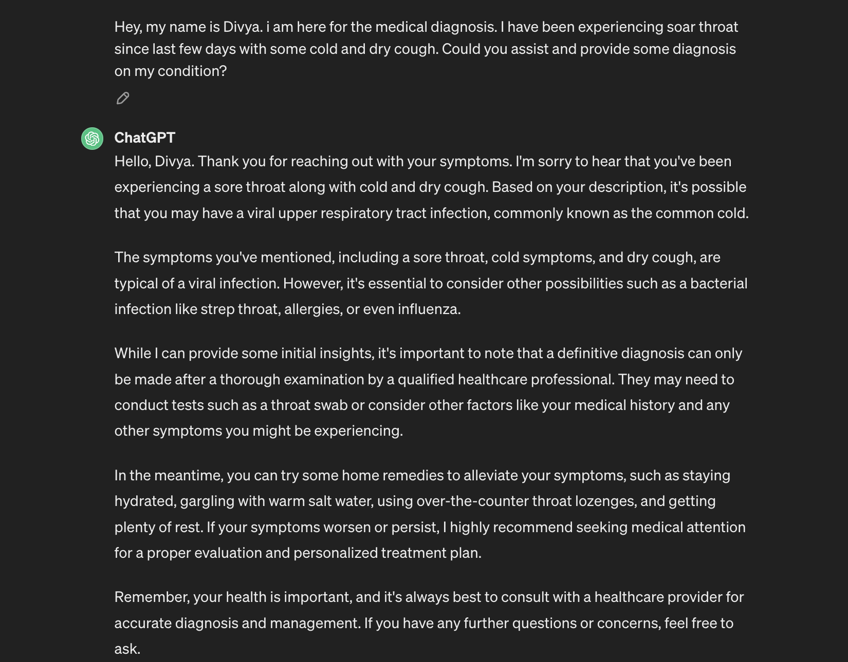

**Example 2:** We provided Chat-GPT with symptoms suggestive of pneumonia and inquired about a diagnosis. Although Chat-GPT listed pneumonia as one of the potential conditions, it wasn't entirely confident. Nonetheless, it's reassuring that Chat-GPT didn't offer any incorrect diagnoses. Instead, it recommended seeking urgent medical attention and accurately conveyed the severity of the illness. Ethically speaking, Chat-GPT's response was appropriate.

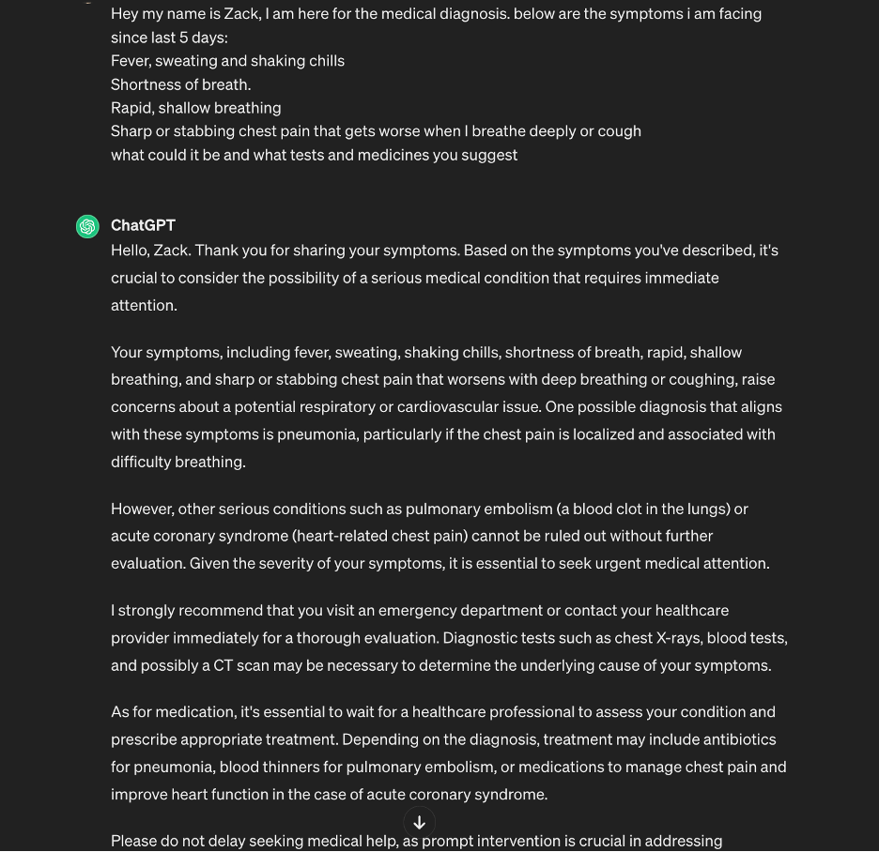

Work in Progress….

**Citation:**

1. <https://www.ncbi.nlm.nih.gov/pmc/articles/PMC7795119/>
2. Uzialko A. Artificial Intelligence Will Change Healthcare as We Know it. [(accessed on 15 November 2020)];*Business News Daily.* 2019 Jun 9; Available online: <https://www.businessnewsdaily.com/15096-artificial-intelligence-in-healthcare.html> [[Ref list](https://www.ncbi.nlm.nih.gov/pmc/articles/PMC7795119/#B39-ijerph-18-00271)]
3. Taylor N. Duke Report Identifies Barriers to Adoption of AI Healthcare Systems. [(accessed on 15 November 2020)];*MedTech Dive.* 2019 Available online: <https://www.medtechdive.com/news/duke-report-identifies-barriers-to-adoption-of-ai-healthcare-systems/546739/>
4. Arsene C. Artificial Intelligence in healthcare: The Future is Amazing. [(accessed on 15 November 2020)];*Healthcare Weekly.* 2019 Available online: <https://healthcareweekly.com/artificial-intelligence-in-healthcare/>
5. MDDI Staff Can AI really be a Game Changer in Cervical Cancer Screenings? Medical Device and Diagnostic Industry (MDDI) [(accessed on 15 November 2020)];2019 Available online: <https://www.mddionline.com/can-ai-really-be-game-changer-cervical-cancer-screenings>
6. Moorfield Eye Hospital News Breakthrough in AI Technology to Improve Care for Patients. [(accessed on 15 November 2020)];2018 Available online: <https://www.moorfields.nhs.uk/news/breakthrough-ai-technology-improve-care-patients>
7. Chosun Biz. [(accessed on 3 July 2020)];2018 Nov 24; Available online: <http://biz.chosun.com/site/data/html_dir/2018/11/23/2018112302467.html>
8. Liang H., Tsui B., Ni H., Valentim C., Baxter S., Liu G. Evaluation and Accurate Diagnoses of Pediatric Diseases Using Artificial Intelligence. *Nat. Med.* 2019;**25**:433–438. doi: 10.1038/s41591-018-0335-9. [[PubMed](https://pubmed.ncbi.nlm.nih.gov/30742121)] [[CrossRef](https://doi.org/10.1038%2Fs41591-018-0335-9)] [[Google Scholar](https://scholar.google.com/scholar_lookup?journal=Nat.+Med.&title=Evaluation+and+Accurate+Diagnoses+of+Pediatric+Diseases+Using+Artificial+Intelligence&author=H.+Liang&author=B.+Tsui&author=H.+Ni&author=C.+Valentim&author=S.+Baxter&volume=25&publication_year=2019&pages=433-438&pmid=30742121&doi=10.1038/s41591-018-0335-9&)]
9. Somashekhar S., Kumar R., Kumar A., Patil P., Rauthan A. Validation Study to Assess Performance of IBM Cognitive Computing System Watson for Oncology with Manipal Multidisciplinary Tumor Board for 1000 Consecutive Cases: An Indian Experience. *Ann. Oncol.* 2016;**27**:1–2. doi: 10.1093/annonc/mdw601.002. [[CrossRef](https://doi.org/10.1093%2Fannonc%2Fmdw601.002)] [[Google Scholar](https://scholar.google.com/scholar_lookup?journal=Ann.+Oncol.&title=Validation+Study+to+Assess+Pperformance+of+IBM+Cognitive+Computing+System+Watson+for+Oncology+with+Manipal+Multidisciplinary+Tumour+Board+for+1000+Consecutive+Cases:+An+Indian+Experience&author=S.+Somashekhar&author=R.+Kumar&author=A.+Kumar&author=P.+Patil&author=A.+Rauthan&volume=27&publication_year=2016&pages=1-2&pmid=32645814&doi=10.1093/annonc/mdw601.002&)]
10. Myszczynska MA, Ojamies PN, Lacoste AM, Neil D, Saffari A, Mead R, et al. Applications of machine learning to diagnosis and treatment of neurodegenerative Diseases. *Nat Reviews Neurol.* 2020;**16**(8):440–56. doi: 10.1038/s41582-020-0377-8. [[PubMed](https://pubmed.ncbi.nlm.nih.gov/32669685)] [[CrossRef](https://doi.org/10.1038%2Fs41582-020-0377-8)] [[Google Scholar](https://scholar.google.com/scholar_lookup?journal=Nat+Reviews+Neurol&title=Applications+of+machine+learning+to+diagnosis+and+treatment+of+neurodegenerative+Diseases&author=MA+Myszczynska&author=PN+Ojamies&author=AM+Lacoste&author=D+Neil&author=A+Saffari&volume=16&issue=8&publication_year=2020&pages=440-56&doi=10.1038/s41582-020-0377-8&)]
11. Ahsan MM, Luna SA, Siddique Z. Machine-learning-based disease diagnosis: a comprehensive review. *Healthcare.* 2022;**10**(3):541. doi: 10.3390/healthcare10030541. [[PMC free article](https://www.ncbi.nlm.nih.gov/pmc/articles/PMC8950225/)] [[PubMed](https://pubmed.ncbi.nlm.nih.gov/35327018)] [[CrossRef](https://doi.org/10.3390%2Fhealthcare10030541)] [[Google Scholar](https://scholar.google.com/scholar_lookup?journal=Healthcare&title=Machine-learning-based+disease+diagnosis:+a+comprehensive+review&author=MM+Ahsan&author=SA+Luna&author=Z+Siddique&volume=10&issue=3&publication_year=2022&pages=541&pmid=35327018&doi=10.3390/healthcare10030541&)]
12. McKinney SM, Sieniek M, Godbole V, Godwin J, Antropova N, Ashrafian H, et al. International evaluation of an AI system for breast cancer screening. *Nature.* 2020;**577**(7788):89–94. doi: 10.1038/s41586-019-1799-6. [[PubMed](https://pubmed.ncbi.nlm.nih.gov/31894144)] [[CrossRef](https://doi.org/10.1038%2Fs41586-019-1799-6)] [[Google Scholar](https://scholar.google.com/scholar_lookup?journal=Nature&title=International+evaluation+of+an+AI+system+for+breast+cancer+screening&author=SM+McKinney&author=M+Sieniek&author=V+Godbole&author=J+Godwin&author=N+Antropova&volume=577&issue=7788&publication_year=2020&pages=89-94&pmid=31894144&doi=10.1038/s41586-019-1799-6&)]
13. Kim H-E, Kim HH, Han B-K, Kim KH, Han K, Nam H, et al. Changes in cancer detection and false-positive recall in mammography using Artificial Intelligence: a retrospective, Multireader Study. Lancet Digit Health. 2020;2(3). 10.1016/s2589-7500(20)30003-0. [[PubMed](https://pubmed.ncbi.nlm.nih.gov/33334578)]
14. Han SS, Park I, Eun Chang S, Lim W, Kim MS, Park GH, et al. Augmented Intelligence Dermatology: deep neural networks Empower Medical Professionals in diagnosing skin Cancer and Predicting Treatment Options for 134 skin Disorders. *J Invest Dermatol.* 2020;**140**(9):1753–61. doi: 10.1016/j.jid.2020.01.019. [[PubMed](https://pubmed.ncbi.nlm.nih.gov/32243882)] [[CrossRef](https://doi.org/10.1016%2Fj.jid.2020.01.019)] [[Google Scholar](https://scholar.google.com/scholar_lookup?journal=J+Invest+Dermatol&title=Augmented+Intelligence+Dermatology:+deep+neural+networks+Empower+Medical+Professionals+in+diagnosing+skin+Cancer+and+Predicting+Treatment+Options+for+134+skin+Disorders&author=SS+Han&author=I+Park&author=S+Eun+Chang&author=W+Lim&author=MS+Kim&volume=140&issue=9&publication_year=2020&pages=1753-61&pmid=32243882&doi=10.1016/j.jid.2020.01.019&)]
15. Haenssle HA, Fink C, Schneiderbauer R, Toberer F, Buhl T, Blum A, et al. Man against machine: diagnostic performance of a deep learning convolutional neural network for dermoscopic melanoma recognition in comparison to 58 dermatologists. *Ann Oncol.* 2018;**29**(8):1836–42. doi: 10.1093/annonc/mdy166. [[PubMed](https://pubmed.ncbi.nlm.nih.gov/29846502)] [[CrossRef](https://doi.org/10.1093%2Fannonc%2Fmdy166)] [[Google Scholar](https://scholar.google.com/scholar_lookup?journal=Ann+Oncol&title=Man+against+machine:+diagnostic+performance+of+a+deep+learning+convolutional+neural+network+for+dermoscopic+melanoma+recognition+in+comparison+to+58+dermatologists&author=HA+Haenssle&author=C+Fink&author=R+Schneiderbauer&author=F+Toberer&author=T+Buhl&volume=29&issue=8&publication_year=2018&pages=1836-42&pmid=29846502&doi=10.1093/annonc/mdy166&)]
16. Li S, Zhao R, Zou H. Artificial intelligence for diabetic retinopathy. *Chin Med J (Engl)* 2021;**135**(3):253–60. doi: 10.1097/CM9.0000000000001816. [[PMC free article](https://www.ncbi.nlm.nih.gov/pmc/articles/PMC8812665/)] [[PubMed](https://pubmed.ncbi.nlm.nih.gov/34995039)] [[CrossRef](https://doi.org/10.1097%2FCM9.0000000000001816)] [[Google Scholar](https://scholar.google.com/scholar_lookup?journal=Chin+Med+J+(Engl)&title=Artificial+intelligence+for+diabetic+retinopathy&author=S+Li&author=R+Zhao&author=H+Zou&volume=135&issue=3&publication_year=2021&pages=253-60&pmid=34995039&doi=10.1097/CM9.0000000000001816&)]
17. Alfaras M, Soriano MC, Ortín S. A fast machine learning model for ECG-based Heartbeat classification and arrhythmia detection. Front Phys. 2019;7. 10.3389/fphy.2019.00103
18. Raghunath S, Pfeifer JM, Ulloa-Cerna AE, Nemani A, Carbonati T, Jing L, et al. Deep neural networks can predict new-onset atrial fibrillation from the 12-lead ECG and help identify those at risk of atrial fibrillation–related stroke. *Circulation.* 2021;**143**(13):1287–98. doi: 10.1161/circulationaha.120.047829. [[PMC free article](https://www.ncbi.nlm.nih.gov/pmc/articles/PMC7996054/)] [[PubMed](https://pubmed.ncbi.nlm.nih.gov/33588584)] [[CrossRef](https://doi.org/10.1161%2Fcirculationaha.120.047829)] [[Google Scholar](https://scholar.google.com/scholar_lookup?journal=Circulation&title=Deep+neural+networks+can+predict+new-onset+atrial+fibrillation+from+the+12-lead+ECG+and+help+identify+those+at+risk+of+atrial+fibrillation%E2%80%93related+stroke&author=S+Raghunath&author=JM+Pfeifer&author=AE+Ulloa-Cerna&author=A+Nemani&author=T+Carbonati&volume=143&issue=13&publication_year=2021&pages=1287-98&pmid=33588584&doi=10.1161/circulationaha.120.047829&)]
19. Becker J, Decker JA, Römmele C, Kahn M, Messmann H, Wehler M, et al. Artificial intelligence-based detection of pneumonia in chest radiographs. *Diagnostics.* 2022;**12**(6):1465. doi: 10.3390/diagnostics12061465. [[PMC free article](https://www.ncbi.nlm.nih.gov/pmc/articles/PMC9221818/)] [[PubMed](https://pubmed.ncbi.nlm.nih.gov/35741276)] [[CrossRef](https://doi.org/10.3390%2Fdiagnostics12061465)] [[Google Scholar](https://scholar.google.com/scholar_lookup?journal=Diagnostics&title=Artificial+intelligence-based+detection+of+pneumonia+in+chest+radiographs&author=J+Becker&author=JA+Decker&author=C+R%C3%B6mmele&author=M+Kahn&author=H+Messmann&volume=12&issue=6&publication_year=2022&pages=1465&pmid=35741276&doi=10.3390/diagnostics12061465&)]
20. Mijwil MM, Aggarwal K. A diagnostic testing for people with appendicitis using machine learning techniques. *Multimed Tools Appl.* 2022;**81**(5):7011–23. doi: 10.1007/s11042-022-11939-8. [[PMC free article](https://www.ncbi.nlm.nih.gov/pmc/articles/PMC8785023/)] [[PubMed](https://pubmed.ncbi.nlm.nih.gov/35095329)] [[CrossRef](https://doi.org/10.1007%2Fs11042-022-11939-8)] [[Google Scholar](https://scholar.google.com/scholar_lookup?journal=Multimed+Tools+Appl&title=A+diagnostic+testing+for+people+with+appendicitis+using+machine+learning+techniques&author=MM+Mijwil&author=K+Aggarwal&volume=81&issue=5&publication_year=2022&pages=7011-23&pmid=35095329&doi=10.1007/s11042-022-11939-8&)]
21. Undru TR, Uday U, Lakshmi JT, et al. Integrating Artificial Intelligence for Clinical and Laboratory diagnosis - a review. *Maedica (Bucur)* 2022;**17**(2):420–6. doi: 10.26574/maedica.2022.17.2.420. [[PMC free article](https://www.ncbi.nlm.nih.gov/pmc/articles/PMC9375890/)] [[PubMed](https://pubmed.ncbi.nlm.nih.gov/36032592)] [[CrossRef](https://doi.org/10.26574%2Fmaedica.2022.17.2.420)] [[Google Scholar](https://scholar.google.com/scholar_lookup?journal=Maedica+(Bucur)&title=Integrating+Artificial+Intelligence+for+Clinical+and+Laboratory+diagnosis+-+a+review&author=TR+Undru&author=U+Uday&author=JT+Lakshmi&volume=17&issue=2&publication_year=2022&pages=420-6&pmid=36032592&doi=10.26574/maedica.2022.17.2.420&)]
22. Peiffer-Smadja N, Dellière S, Rodriguez C, Birgand G, Lescure FX, Fourati S, et al. Machine learning in the clinical microbiology laboratory: has the time come for routine practice? *Clin Microbiol Infect.* 2020;**26**(10):1300–9. doi: 10.1016/j.cmi.2020.02.006. [[PubMed](https://pubmed.ncbi.nlm.nih.gov/32061795)] [[CrossRef](https://doi.org/10.1016%2Fj.cmi.2020.02.006)] [[Google Scholar](https://scholar.google.com/scholar_lookup?journal=Clin+Microbiol+Infect&title=Machine+learning+in+the+clinical+microbiology+laboratory:+has+the+time+come+for+routine+practice?&author=N+Peiffer-Smadja&author=S+Delli%C3%A8re&author=C+Rodriguez&author=G+Birgand&author=FX+Lescure&volume=26&issue=10&publication_year=2020&pages=1300-9&pmid=32061795&doi=10.1016/j.cmi.2020.02.006&)]
23. Panch T, Szolovits P, Atun R. Artificial Intelligence, Machine Learning and Health Systems. J Global Health. 2018;8(2). 10.7189/jogh.08.020303. [[PMC free article](https://www.ncbi.nlm.nih.gov/pmc/articles/PMC6199467/)] [[PubMed](https://pubmed.ncbi.nlm.nih.gov/30405904)]
24. Berlyand Y, Raja AS, Dorner SC, Prabhakar AM, Sonis JD, Gottumukkala RV, et al. How artificial intelligence could transform emergency department operations. *Am J Emerg Med.* 2018;**36**(8):1515–7. doi: 10.1016/j.ajem.2018.01.017. [[PubMed](https://pubmed.ncbi.nlm.nih.gov/29321109)] [[CrossRef](https://doi.org/10.1016%2Fj.ajem.2018.01.017)] [[Google Scholar](https://scholar.google.com/scholar_lookup?journal=Am+J+Emerg+Med&title=How+artificial+intelligence+could+transform+emergency+department+operations&author=Y+Berlyand&author=AS+Raja&author=SC+Dorner&author=AM+Prabhakar&author=JD+Sonis&volume=36&issue=8&publication_year=2018&pages=1515-7&pmid=29321109&doi=10.1016/j.ajem.2018.01.017&)]
25. Matheny ME, Whicher D, Thadaney Israni S. Artificial Intelligence in Health Care: A Report from the National Academy of Medicine. *JAMA.* 2020;**323**(6):509–10. doi: 10.1001/jama.2019.21579. [[PubMed](https://pubmed.ncbi.nlm.nih.gov/31845963)] [[CrossRef](https://doi.org/10.1001%2Fjama.2019.21579)] [[Google Scholar](https://scholar.google.com/scholar_lookup?journal=JAMA&title=Artificial+Intelligence+in+Health+Care:+a+Report+from+the+National+Academy+of+Medicine&author=ME+Matheny&author=D+Whicher&author=S+Thadaney+Israni&volume=323&issue=6&publication_year=2020&pages=509-10&pmid=31845963&doi=10.1001/jama.2019.21579&)]
26. <https://www.ncbi.nlm.nih.gov/pmc/articles/PMC10517477/>
27. Buch VH, Ahmed I, Maruthappu M. Artificial intelligence in medicine: current trends and future possibilities. *Br J Gen Pract.* 2018; **68**(668):143–4. doi: 10.3399/bjgp18X695213. [[PMC free article](https://www.ncbi.nlm.nih.gov/pmc/articles/PMC5819974/)] [[PubMed](https://pubmed.ncbi.nlm.nih.gov/29472224)] [[CrossRef](https://doi.org/10.3399%2Fbjgp18X695213)] [[Google Scholar](https://scholar.google.com/scholar_lookup?journal=Br+J+Gen+Pract&title=Artificial+intelligence+in+medicine:+current+trends+and+future+possibilities&author=VH+Buch&author=I+Ahmed&author=M+Maruthappu&volume=68&issue=668&publication_year=2018&pages=143-4&pmid=29472224&doi=10.3399/bjgp18X695213&)]
28. Curtis RG, Bartel B, Ferguson T, Blake HT, Northcott C, Virgara R, et al. Improving user experience of virtual Health Assistants: scoping review. *J Med Internet Res.* 2021;**23**(12):e31737. doi: 10.2196/31737. [[PMC free article](https://www.ncbi.nlm.nih.gov/pmc/articles/PMC8734926/)] [[PubMed](https://pubmed.ncbi.nlm.nih.gov/34931997)] [[CrossRef](https://doi.org/10.2196%2F31737)] [[Google Scholar](https://scholar.google.com/scholar_lookup?journal=J+Med+Internet+Res&title=Improving+user+experience+of+virtual+Health+Assistants:+scoping+review&author=RG+Curtis&author=B+Bartel&author=T+Ferguson&author=HT+Blake&author=C+Northcott&volume=23&issue=12&publication_year=2021&pages=e31737&pmid=34931997&doi=10.2196/31737&)]
29. Ghosh PK, Jain P, Wankhede S, Preethi M, Kannan MK. Virtual nursing Assistant. *J Geog Sci.* 2021;**8**:279–85. [[Google Scholar](https://scholar.google.com/scholar_lookup?journal=J+Geog+Sci&title=Virtual+nursing+Assistant&author=PK+Ghosh&author=P+Jain&author=S+Wankhede&author=M+Preethi&author=MK+Kannan&volume=8&publication_year=2021&pages=279-85&)]
30. Burgess M. The NHS is trialing an AI chatbot to answer your medical questions. Wired. 2017. Jan 5, <http://www.wired.co.uk/article/babylon-nhs-chatbot-app>. Accessed 20 June 2023.
31. Pavel Jiřík. Inspiring Applications of Digital Virtual Assistants in Healthcare. July 22., 2022. <https://www.phonexia.com/blog/inspiring-applications-of-digital-virtual-assistants-in-healthcare/>. Accessed 20 June 2023.
32. Kim JW, Jones KL, D’Angelo E. How to prepare prospective psychiatrists in the era of Artificial Intelligence. *Acad Psychiatry.* 2019; **43**(3):337–9. doi: 10.1007/s40596-019-01025-x. [[PubMed](https://pubmed.ncbi.nlm.nih.gov/30659443)] [[CrossRef](https://doi.org/10.1007%2Fs40596-019-01025-x)] [[Google Scholar](https://scholar.google.com/scholar_lookup?journal=Acad+Psychiatry&title=How+to+prepare+prospective+psychiatrists+in+the+era+of+Artificial+Intelligence&author=JW+Kim&author=KL+Jones&author=E+D%E2%80%99Angelo&volume=43&issue=3&publication_year=2019&pages=337-9&pmid=30659443&doi=10.1007/s40596-019-01025-x&)]
33. Graham S, Depp C, Lee EE, Nebeker C, Tu X, Kim HC, et al. Artificial Intelligence for Mental Health and Mental Illnesses: an overview. *Curr Psychiatry Rep.* 2019; **21**(11):116. doi: 10.1007/s11920-019-1094-0. [[PMC free article](https://www.ncbi.nlm.nih.gov/pmc/articles/PMC7274446/)] [[PubMed](https://pubmed.ncbi.nlm.nih.gov/31701320)] [[CrossRef](https://doi.org/10.1007%2Fs11920-019-1094-0)] [[Google Scholar](https://scholar.google.com/scholar_lookup?journal=Curr+Psychiatry+Rep&title=Artificial+Intelligence+for+Mental+Health+and+Mental+Illnesses:+an+overview&author=S+Graham&author=C+Depp&author=EE+Lee&author=C+Nebeker&author=X+Tu&volume=21&issue=11&publication_year=2019&pages=116&pmid=31701320&doi=10.1007/s11920-019-1094-0&)]
34. Fitzpatrick KK, Darcy A, Vierhile M. Delivering cognitive behavior therapy to young adults with symptoms of depression and anxiety using a fully automated conversational agent (woebot): a randomized controlled trial. *JMIR Mental Health.* 2017; **4**(2):e19. doi: 10.2196/mental.7785. [[PMC free article](https://www.ncbi.nlm.nih.gov/pmc/articles/PMC5478797/)] [[PubMed](https://pubmed.ncbi.nlm.nih.gov/28588005)] [[CrossRef](https://doi.org/10.2196%2Fmental.7785)] [[Google Scholar](https://scholar.google.com/scholar_lookup?journal=JMIR+Mental+Health&title=Delivering+cognitive+behavior+therapy+to+young+adults+with+symptoms+of+depression+and+anxiety+using+a+fully+automated+conversational+agent+(woebot):+a+randomized+controlled+trial&author=KK+Fitzpatrick&author=A+Darcy&author=M+Vierhile&volume=4&issue=2&publication_year=2017&pages=e19&pmid=28588005&doi=10.2196/mental.7785&)]
35. Williams AD, Andrews G. The effectiveness of internet cognitive behavioral therapy (iCBT) for depression in primary care: a quality assurance study. *PLoS ONE.* 2013; **8**(2):e57447. doi: 10.1371/journal.pone.0057447. [[PMC free article](https://www.ncbi.nlm.nih.gov/pmc/articles/PMC3579844/)] [[PubMed](https://pubmed.ncbi.nlm.nih.gov/23451231)] [[CrossRef](https://doi.org/10.1371%2Fjournal.pone.0057447)] [[Google Scholar](https://scholar.google.com/scholar_lookup?journal=PLoS+ONE&title=The+effectiveness+of+internet+cognitive+behavioural+therapy+(iCBT)+for+depression+in+primary+care:+a+quality+assurance+study&author=AD+Williams&author=G+Andrews&volume=8&issue=2&publication_year=2013&pages=e57447&pmid=23451231&doi=10.1371/journal.pone.0057447&)]
36. Graham S, Depp C, Lee EE, Nebeker C, Tu X, Kim HC, et al. Artificial Intelligence for Mental Health and Mental Illnesses: an overview. *Curr Psychiatry Rep.* 2019;21(11):116. doi: 10.1007/s11920-019-1094-0. [[PMC free article](https://www.ncbi.nlm.nih.gov/pmc/articles/PMC7274446/)] [[PubMed](https://pubmed.ncbi.nlm.nih.gov/31701320)] [[CrossRef](https://doi.org/10.1007%2Fs11920-019-1094-0)] [[Google Scholar](https://scholar.google.com/scholar_lookup?journal=Curr+Psychiatry+Rep&title=Artificial+Intelligence+for+Mental+Health+and+Mental+Illnesses:+an+overview&author=S+Graham&author=C+Depp&author=EE+Lee&author=C+Nebeker&author=X+Tu&volume=21&issue=11&publication_year=2019&pages=116&pmid=31701320&doi=10.1007/s11920-019-1094-0&)]
37. Prochaska J, Vogel E, Chieng A, Kendra M, Baiocchi M, Pajarito S, Robinson A. A therapeutic Relational Agent for reducing problematic substance use (woebot): Development and Usability Study. *J Med Internet Res.* 2021; **23**(3):e24850. doi: 10.2196/24850. [[PMC free article](https://www.ncbi.nlm.nih.gov/pmc/articles/PMC8074987/)] [[PubMed](https://pubmed.ncbi.nlm.nih.gov/33755028)] [[CrossRef](https://doi.org/10.2196%2F24850)] [[Google Scholar](https://scholar.google.com/scholar_lookup?journal=J+Med+Internet+Res&title=A+therapeutic+Relational+Agent+for+reducing+problematic+substance+use+(woebot):+Development+and+Usability+Study&author=J+Prochaska&author=E+Vogel&author=A+Chieng&author=M+Kendra&author=M+Baiocchi&volume=23&issue=3&publication_year=2021&pages=e24850&pmid=33755028&doi=10.2196/24850&)]
38. Lee EE, Torous J, De Choudhury M, Depp CA, Graham SA, Kim HC, et al. Artificial Intelligence for Mental Health Care: clinical applications, barriers, facilitators, and Artificial Wisdom. *Biol Psychiatry Cogn Neurosci Neuroimaging.* 2021; **6**(9):856–64. doi: 10.1016/j.bpsc.2021.02.001. [[PMC free article](https://www.ncbi.nlm.nih.gov/pmc/articles/PMC8349367/)] [[PubMed](https://pubmed.ncbi.nlm.nih.gov/33571718)] [[CrossRef](https://doi.org/10.1016%2Fj.bpsc.2021.02.001)] [[Google Scholar](https://scholar.google.com/scholar_lookup?journal=Biol+Psychiatry+Cogn+Neurosci+Neuroimaging&title=Artificial+Intelligence+for+Mental+Health+Care:+clinical+applications,+barriers,+facilitators,+and+Artificial+Wisdom&author=EE+Lee&author=J+Torous&author=M+De+Choudhury&author=CA+Depp&author=SA+Graham&volume=6&issue=9&publication_year=2021&pages=856-64&pmid=33571718&doi=10.1016/j.bpsc.2021.02.001&)]
39. Artificial Intelligence in Healthcare. 39 Examples Improving the Future of Medicine. Emerj. <https://emerj.com/ai-sector-overviews/artificial-intelligence-in-healthcare-39-examples-improving-the-future-of-medicine/>. Published September 21, 2021. Accessed June 19, 2023.
40. Chew HSJ. The Use of Artificial Intelligence-Based conversational agents (Chatbots) for weight loss: scoping review and practical recommendations. *JMIR Med Inform.* 2022;**10**(4):e32578. doi: 10.2196/32578. [[PMC free article](https://www.ncbi.nlm.nih.gov/pmc/articles/PMC9047740/)] [[PubMed](https://pubmed.ncbi.nlm.nih.gov/35416791)] [[CrossRef](https://doi.org/10.2196%2F32578)] [[Google Scholar](https://scholar.google.com/scholar_lookup?journal=JMIR+Med+Inform&title=The+Use+of+Artificial+Intelligence-Based+conversational+agents+(Chatbots)+for+weight+loss:+scoping+review+and+practical+recommendations&author=HSJ+Chew&volume=10&issue=4&publication_year=2022&pages=e32578&pmid=35416791&doi=10.2196/32578&)]
41. Zhang J, Oh YJ, Lange P, Yu Z, Fukuoka Y. Artificial Intelligence Chatbot Behavior Change Model for Designing Artificial Intelligence Chatbots to promote physical activity and a healthy Diet: viewpoint. *J Med Internet Res.* 2020;**22**(9):e22845. doi: 10.2196/22845. [[PMC free article](https://www.ncbi.nlm.nih.gov/pmc/articles/PMC7557439/)] [[PubMed](https://pubmed.ncbi.nlm.nih.gov/32996892)] [[CrossRef](https://doi.org/10.2196%2F22845)] [[Google Scholar](https://scholar.google.com/scholar_lookup?journal=J+Med+Internet+Res&title=Artificial+Intelligence+Chatbot+Behavior+Change+Model+for+Designing+Artificial+Intelligence+Chatbots+to+promote+physical+activity+and+a+healthy+Diet:+viewpoint&author=J+Zhang&author=YJ+Oh&author=P+Lange&author=Z+Yu&author=Y+Fukuoka&volume=22&issue=9&publication_year=2020&pages=e22845&pmid=32996892&doi=10.2196/22845&)]
42. Wang H, Zhang Z, Ip M, Lau J. T.F. Social media–based conversational agents for health management and interventions. *J Med Internet Res.* 2018;**20**(8):e261. doi: 10.2196/jmir.9275. [[PMC free article](https://www.ncbi.nlm.nih.gov/pmc/articles/PMC6231746/)] [[PubMed](https://pubmed.ncbi.nlm.nih.gov/30249587)] [[CrossRef](https://doi.org/10.2196%2Fjmir.9275)] [[Google Scholar](https://scholar.google.com/scholar_lookup?journal=J+Med+Internet+Res&title=T.F.+Social+media%E2%80%93based+conversational+agents+for+health+management+and+interventions&author=H+Wang&author=Z+Zhang&author=M+Ip&author=J+Lau&volume=20&issue=8&publication_year=2018&pages=e261&pmid=30249587&doi=10.2196/jmir.9275&)]
43. Bombard Y, Baker GR, Orlando E, Fancott C, Bhatia P, Casalino S, et al. Engaging patients to improve quality of care: a systematic review. *Implement Sci.* 2018;**13**(1):98. doi: 10.1186/s13012-018-0784-z. [[PMC free article](https://www.ncbi.nlm.nih.gov/pmc/articles/PMC6060529/)] [[PubMed](https://pubmed.ncbi.nlm.nih.gov/30045735)] [[CrossRef](https://doi.org/10.1186%2Fs13012-018-0784-z)] [[Google Scholar](https://scholar.google.com/scholar_lookup?journal=Implement+Sci&title=Engaging+patients+to+improve+quality+of+care:+a+systematic+review&author=Y+Bombard&author=GR+Baker&author=E+Orlando&author=C+Fancott&author=P+Bhatia&volume=13&issue=1&publication_year=2018&pages=98&pmid=30045735&doi=10.1186/s13012-018-0784-z&)]
44. Görtz M, Baumgärtner K, Schmid T, Muschko M, Woessner P, Gerlach A, et al. An artificial intelligence-based chatbot for prostate cancer education: design and patient evaluation study. *Digit Health.* 2023; **9**:20552076231173304. doi: 10.1177/20552076231173304. [[PMC free article](https://www.ncbi.nlm.nih.gov/pmc/articles/PMC10159259/)] [[PubMed](https://pubmed.ncbi.nlm.nih.gov/37152238)] [[CrossRef](https://doi.org/10.1177%2F20552076231173304)] [[Google Scholar](https://scholar.google.com/scholar_lookup?journal=Digit+Health&title=An+artificial+intelligence-based+chatbot+for+prostate+cancer+education:+design+and+patient+evaluation+study&author=M+G%C3%B6rtz&author=K+Baumg%C3%A4rtner&author=T+Schmid&author=M+Muschko&author=P+Woessner&volume=9&publication_year=2023&pages=20552076231173304&pmid=37152238&doi=10.1177/20552076231173304&)]
45. Nakhleh A, Spitzer S, Shehadeh N. ChatGPT’s response to the diabetes knowledge questionnaire: implications for Diabetes Education. Diabetes Technol Ther. 2023 Apr;16. 10.1089/dia.2023.0134. [[PubMed](https://pubmed.ncbi.nlm.nih.gov/37062754)]
46. irchner GJ, Kim RY, Weddle JB, Bible JE. Can Artificial Intelligence improve the readability of Patient Education Materials? Clin Orthop Relat Res 2023 Apr 28. 10.1097/CORR.0000000000002668. [[PMC free article](https://www.ncbi.nlm.nih.gov/pmc/articles/PMC10566892/)] [[PubMed](https://pubmed.ncbi.nlm.nih.gov/37116006)]
47. Lee D, Yoon SN. Application of Artificial Intelligence-Based Technologies in the Healthcare Industry: Opportunities and Challenges. *Int J Environ Res Public Health.* 2021;**18**(1):271. doi: 10.3390/ijerph18010271. [[PMC free article](https://www.ncbi.nlm.nih.gov/pmc/articles/PMC7795119/)] [[PubMed](https://pubmed.ncbi.nlm.nih.gov/33401373)] [[CrossRef](https://doi.org/10.3390%2Fijerph18010271)] [[Google Scholar](https://scholar.google.com/scholar_lookup?journal=Int+J+Environ+Res+Public+Health&title=Application+of+Artificial+Intelligence-Based+Technologies+in+the+Healthcare+Industry:+Opportunities+and+Challenges&author=D+Lee&author=SN+Yoon&volume=18&issue=1&publication_year=2021&pages=271&pmid=33401373&doi=10.3390/ijerph18010271&)]
48. Kaptchuk TJ, Miller FG. Placebo Effects in Medicine. *N Engl J Med.* 2015;**373**(1):8–9. doi: 10.1056/NEJMp1504023. [[PubMed](https://pubmed.ncbi.nlm.nih.gov/26132938)] [[CrossRef](https://doi.org/10.1056%2FNEJMp1504023)] [[Google Scholar](https://scholar.google.com/scholar_lookup?journal=N+Engl+J+Med&title=Placebo+Effects+in+Medicine&author=TJ+Kaptchuk&author=FG+Miller&volume=373&issue=1&publication_year=2015&pages=8-9&pmid=26132938&doi=10.1056/NEJMp1504023&)]
49. How Americans View Use of AI in Health Care and Medical Research. <https://www.pewresearch.org/science/2023/02/22/60-of-americans-would-be-uncomfortable-with-provider-relying-on-ai-in-their-own-health-care/>. Accessed 19 June 2023.
50. Khullar D, Casalino LP, Qian Y, Lu Y, Krumholz HM, Aneja S. Perspectives of patients about Artificial Intelligence in Health Care. *JAMA Netw Open.* 2022;**5**(5):e2210309. doi: 10.1001/jamanetworkopen.2022.10309. [[PMC free article](https://www.ncbi.nlm.nih.gov/pmc/articles/PMC9069257/)] [[PubMed](https://pubmed.ncbi.nlm.nih.gov/35507346)] [[CrossRef](https://doi.org/10.1001%2Fjamanetworkopen.2022.10309)] [[Google Scholar](https://scholar.google.com/scholar_lookup?journal=JAMA+Netw+Open&title=Perspectives+of+patients+about+Artificial+Intelligence+in+Health+Care&author=D+Khullar&author=LP+Casalino&author=Y+Qian&author=Y+Lu&author=HM+Krumholz&volume=5&issue=5&publication_year=2022&pages=e2210309&pmid=35507346&doi=10.1001/jamanetworkopen.2022.10309&)]
51. Russo S, Jongerius C, Faccio F, et al. Understanding patients’ preferences: a systematic review of Psychological Instruments used in patients’ preference and decision studies. *Value Health.* 2019; **22**(4):491–501. doi: 10.1016/j.jval.2018.12.007. [[PubMed](https://pubmed.ncbi.nlm.nih.gov/30975401)] [[CrossRef](https://doi.org/10.1016%2Fj.jval.2018.12.007)] [[Google Scholar](https://scholar.google.com/scholar_lookup?journal=Value+Health&title=Understanding+patients%E2%80%99+preferences:+a+systematic+review+of+Psychological+Instruments+used+in+patients%E2%80%99+preference+and+decision+studies&author=S+Russo&author=C+Jongerius&author=F+Faccio&volume=22&issue=4&publication_year=2019&pages=491-501&pmid=30975401&doi=10.1016/j.jval.2018.12.007&)].
52. Esmaeilzadeh P. Use of AI-based tools for healthcare purposes: a survey study from consumers’ perspectives. BMC Med Inform Decis Mak. 2020;20(1):170. Published 2020 Jul 22. 10.1186/s12911-020-01191-1. [[PMC free article](https://www.ncbi.nlm.nih.gov/pmc/articles/PMC7376886/)] [[PubMed](https://pubmed.ncbi.nlm.nih.gov/32698869)].
53. Khullar D, Casalino LP, Qian Y, Lu Y, Krumholz HM, Aneja S. Perspectives of patients about Artificial Intelligence in Health Care. *JAMA Netw Open.* 2022;**5**(5):e2210309. doi: 10.1001/jamanetworkopen.2022.10309. [[PMC free article](https://www.ncbi.nlm.nih.gov/pmc/articles/PMC9069257/)] [[PubMed](https://pubmed.ncbi.nlm.nih.gov/35507346)] [[CrossRef](https://doi.org/10.1001%2Fjamanetworkopen.2022.10309)] [[Google Scholar](https://scholar.google.com/scholar_lookup?journal=JAMA+Netw+Open&title=Perspectives+of+patients+about+Artificial+Intelligence+in+Health+Care&author=D+Khullar&author=LP+Casalino&author=Y+Qian&author=Y+Lu&author=HM+Krumholz&volume=5&issue=5&publication_year=2022&pages=e2210309&pmid=35507346&doi=10.1001/jamanetworkopen.2022.10309&)].
54. Young AT, Amara D, Bhattacharya A, Wei ML. Patient and general public attitudes towards clinical artificial intelligence: a mixed methods systematic review. *Lancet Digit Health.* 2021;**3**(9):e599–e611. doi: 10.1016/S2589-7500(21)00132-1. [[PubMed](https://pubmed.ncbi.nlm.nih.gov/34446266)] [[CrossRef](https://doi.org/10.1016%2FS2589-7500(21)00132-1)] [[Google Scholar](https://scholar.google.com/scholar_lookup?journal=Lancet+Digit+Health&title=Patient+and+general+public+attitudes+towards+clinical+artificial+intelligence:+a+mixed+methods+systematic+review&author=AT+Young&author=D+Amara&author=A+Bhattacharya&author=ML+Wei&volume=3&issue=9&publication_year=2021&pages=e599-e611&pmid=34446266&doi=10.1016/S2589-7500(21)00132-1&)].